Sqoop Pb07

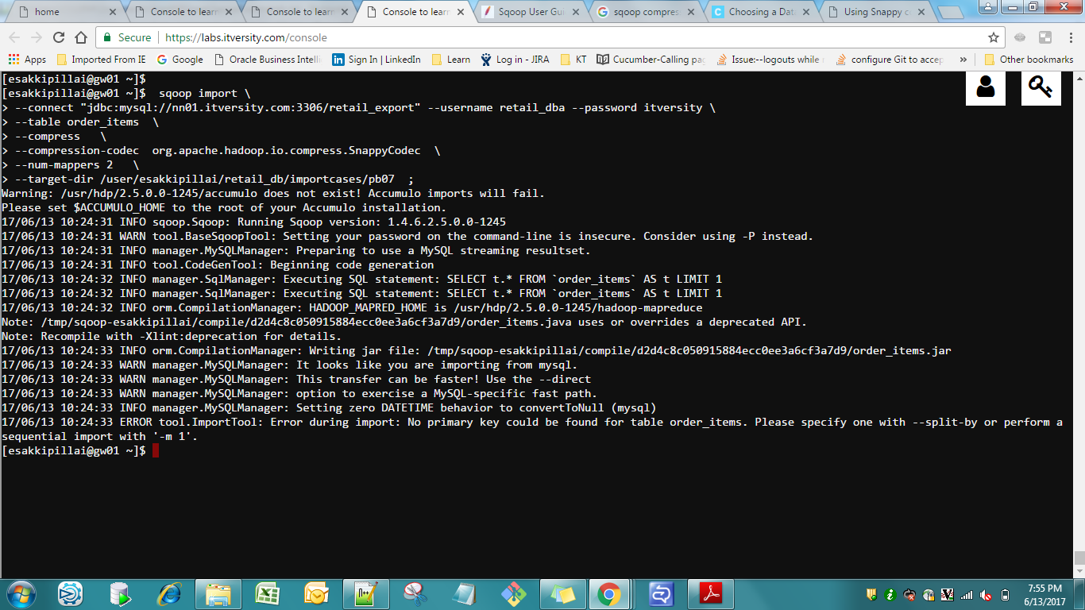

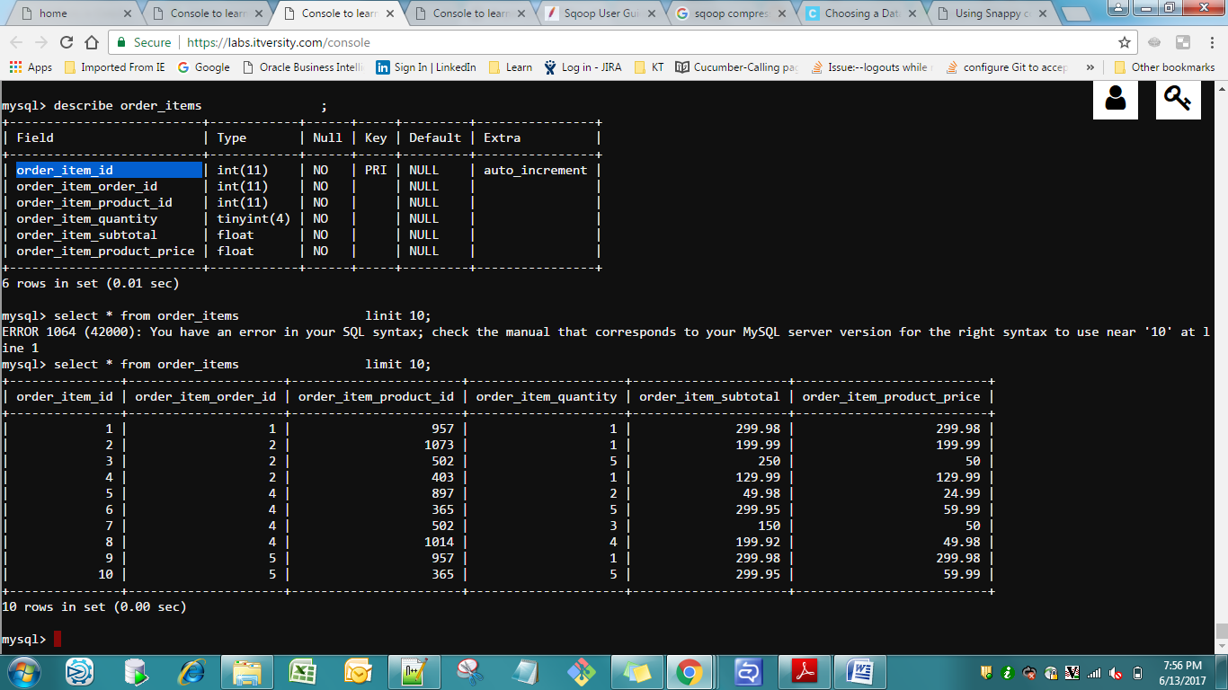

Order_item_id is primary key

Y it throws to add the split-by column ? or make it as –m 1

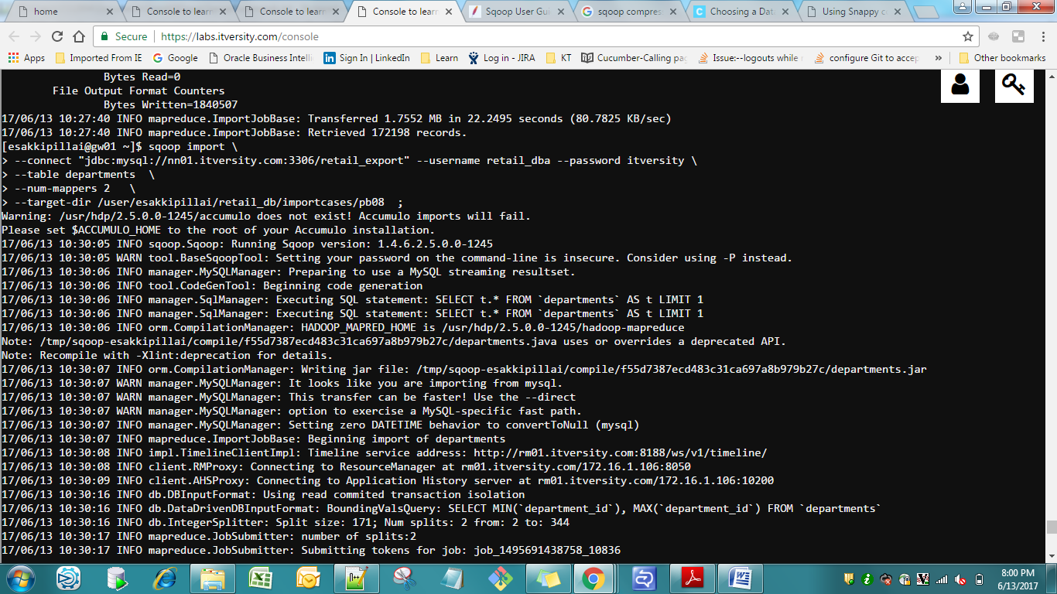

Incremental Import

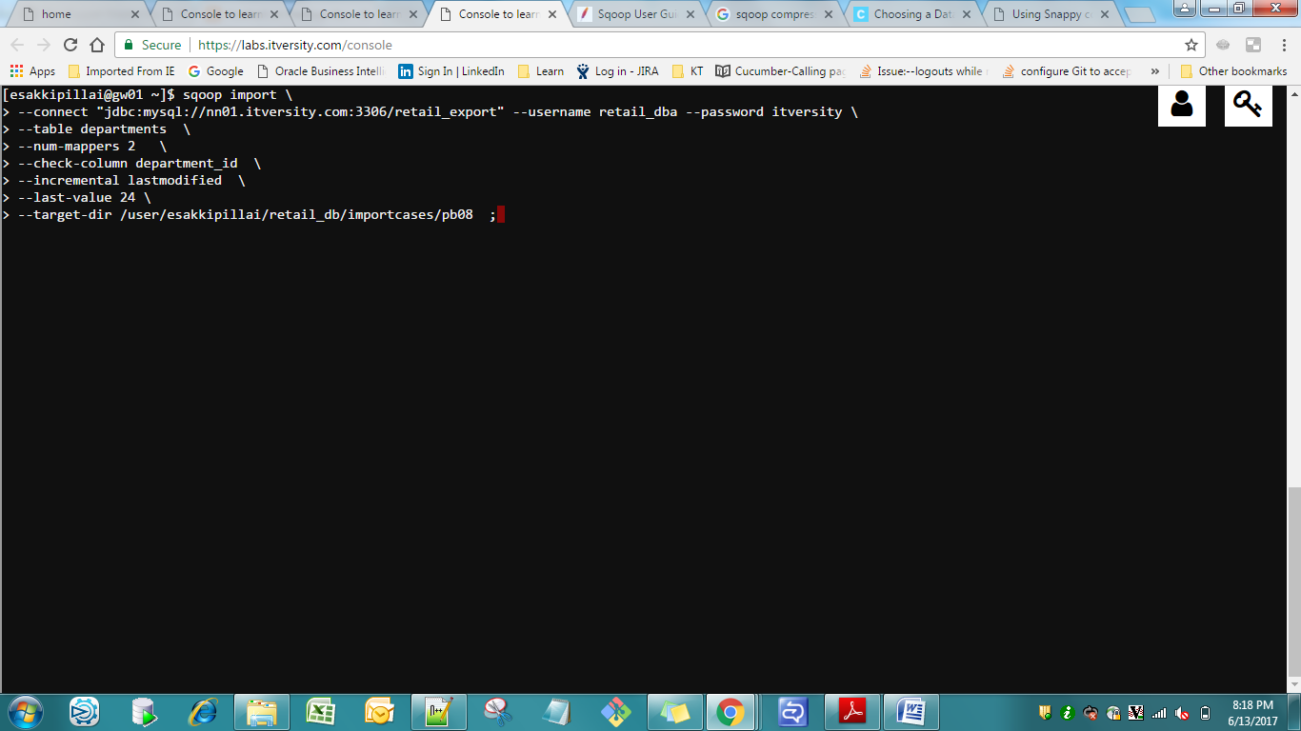

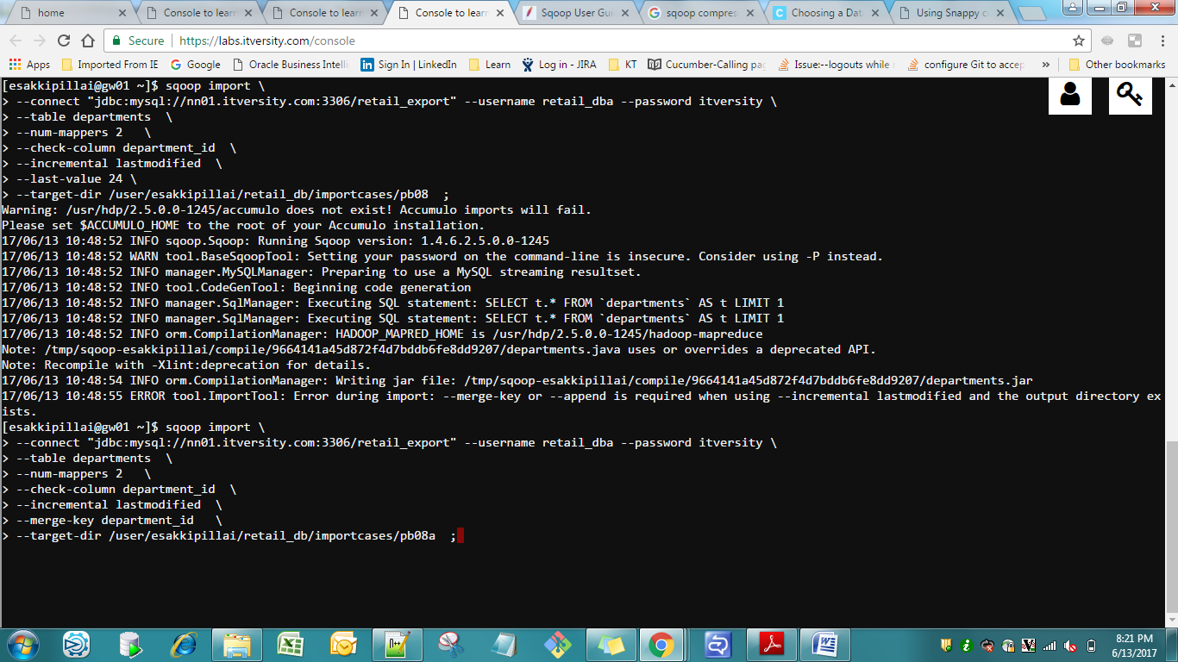

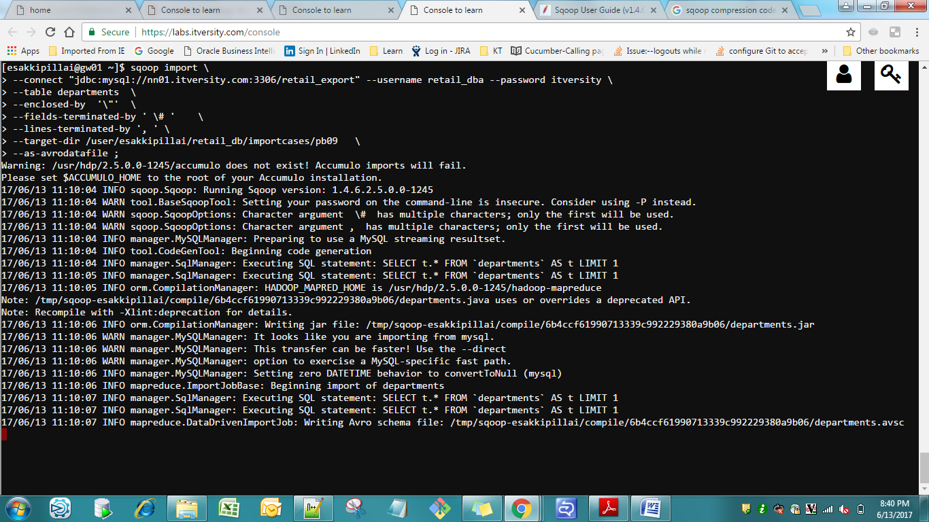

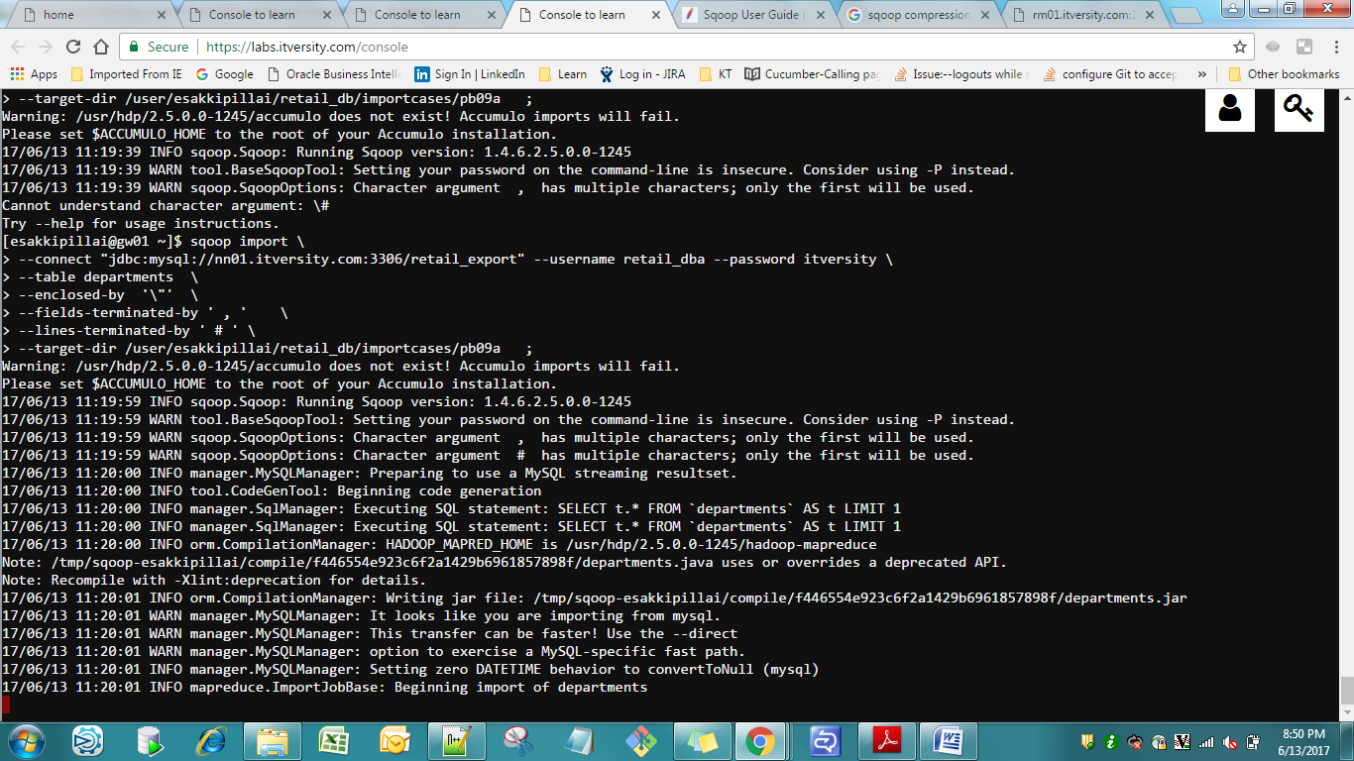

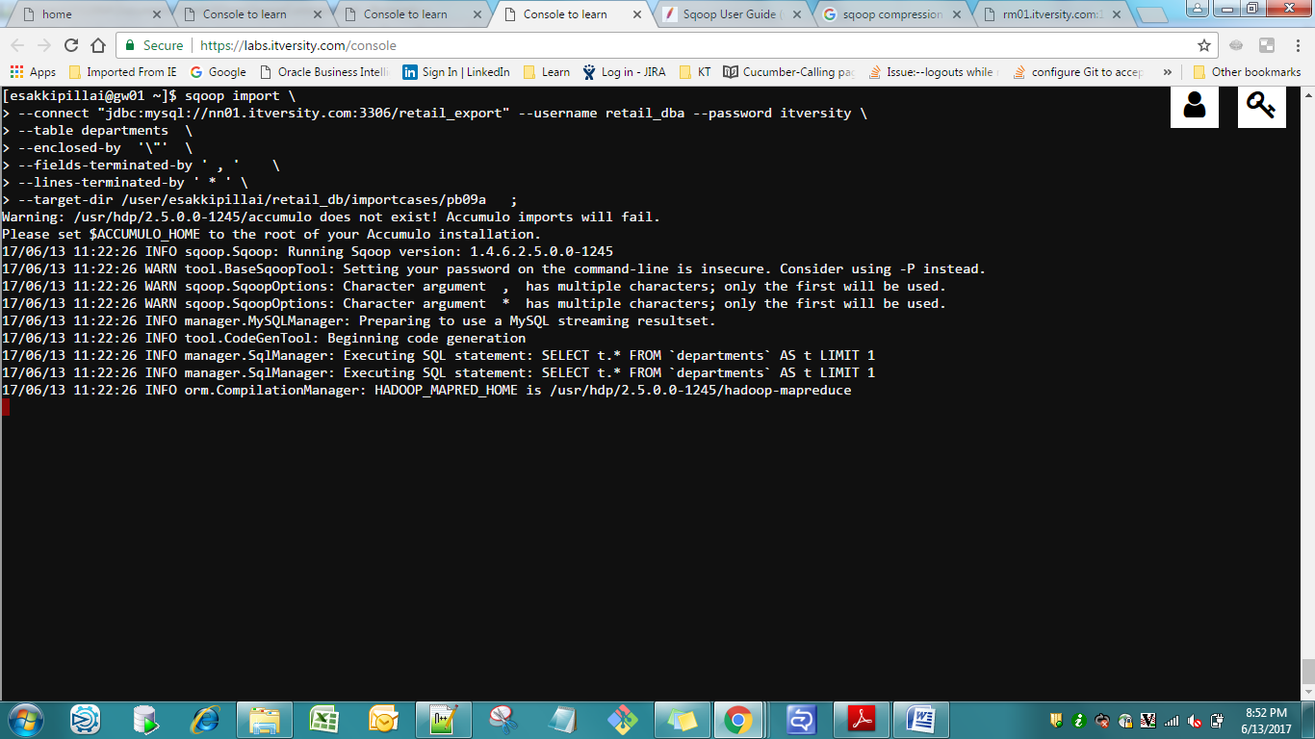

PB 09

Change the Output Delimiter

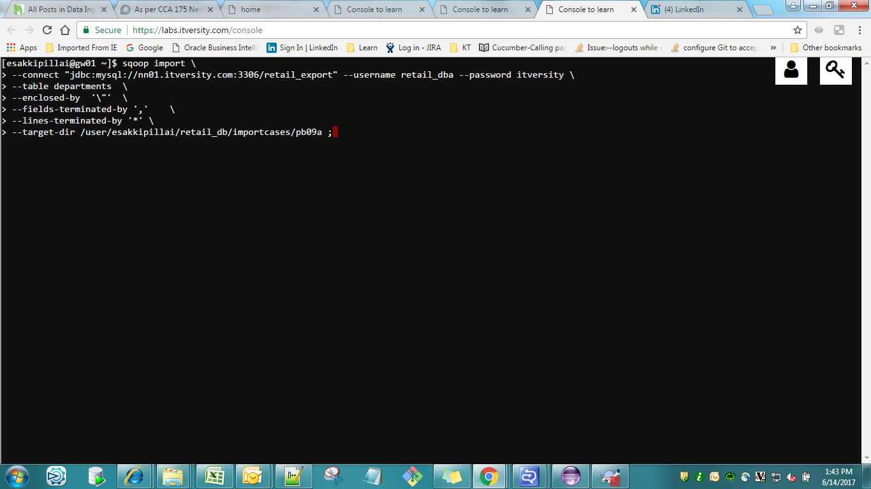

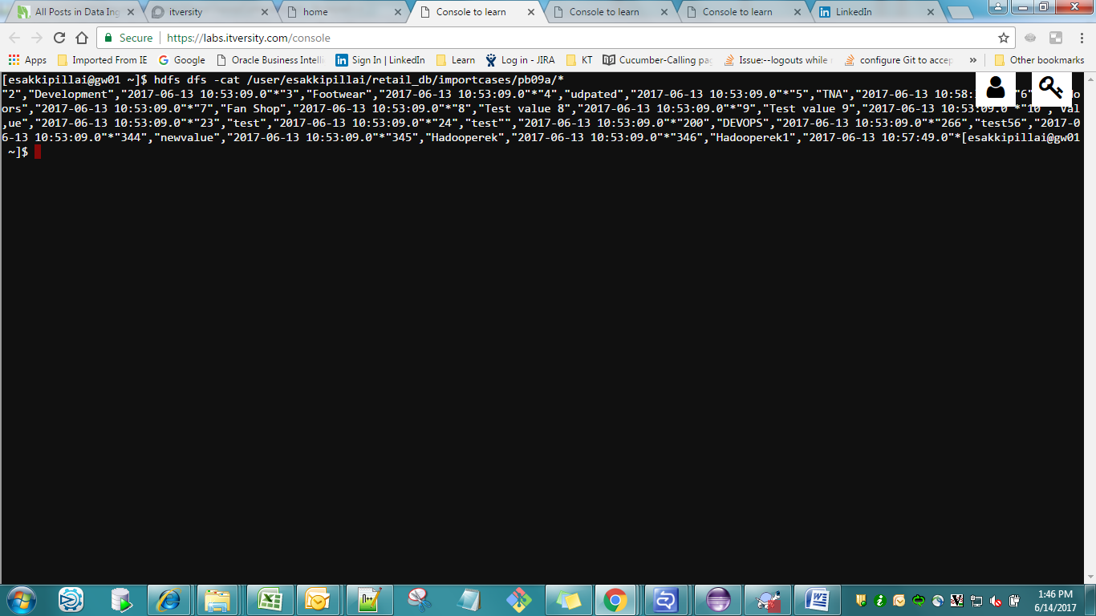

[esakkipillai@gw01 ~]$ hdfs dfs -cat /user/esakkipillai/retail_db/importcases/pb09a/*

"2","Development","2017-06-13 10:53:09.0"*"3","Footwear","2017-06-13 10:53:09.0"*"4","udpated","2017-06-13 10:53:09.0"*"5","TNA","2017-06-13 10:58:30.0"*"6","Outdoors","2017-06-13 10:53:09.0"*"7","Fan Shop","2017-06-13 10:53:09.0"*"8","Test value 8","2017-06-13 10:53:09.0"*"9","Test value 9","2017-06-13 10:53:09.0"*"10","Val,ue","2017-06-13 10:53:09.0"*"23","test","2017-06-13 10:53:09.0"*"24","test"","2017-06-13 10:53:09.0"*"200","DEVOPS","2017-06-13 10:53:09.0"*"266","test56","2017-06-13 10:53:09.0"*"344","newvalue","2017-06-13 10:53:09.0"*"345","Hadooperek","2017-06-13 10:53:09.0"*"346","Hadooperek1","2017-06-13 10:57:49.0"*[esakkipillai@gw01 ~]$

Pb09b

Change the Output Delimiter as below

Fields ^^ lines $ enclosed by “

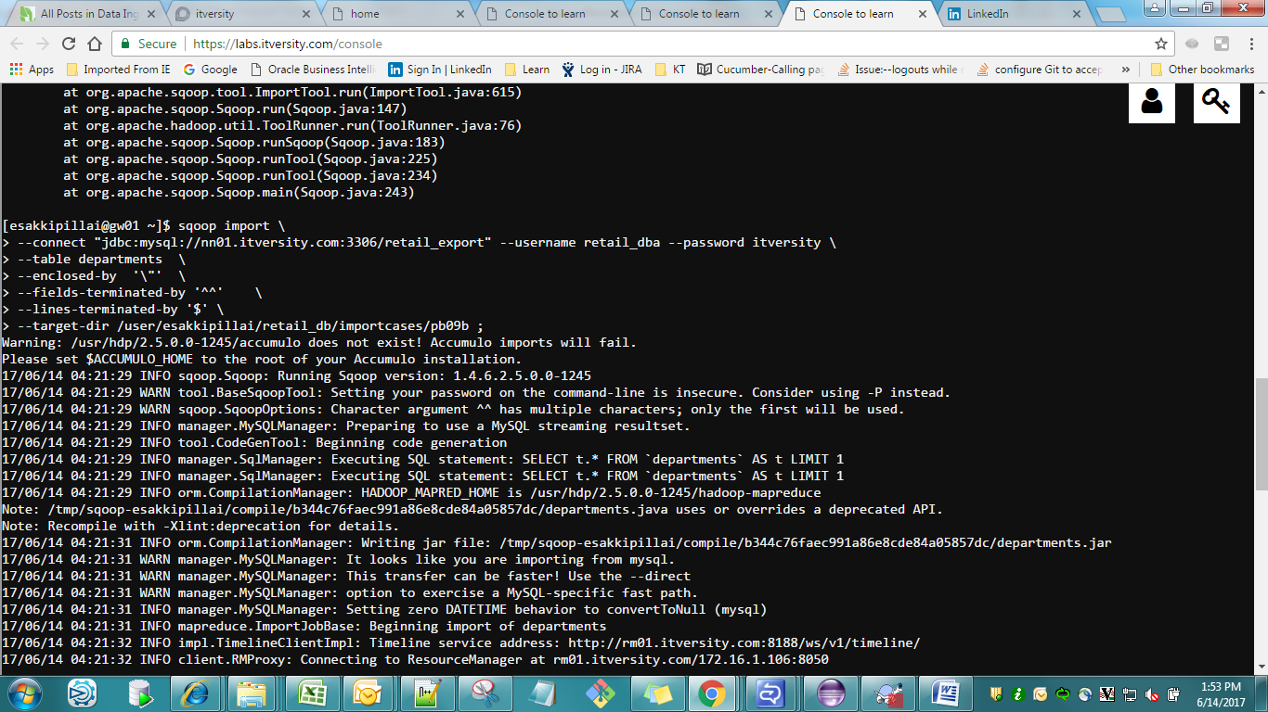

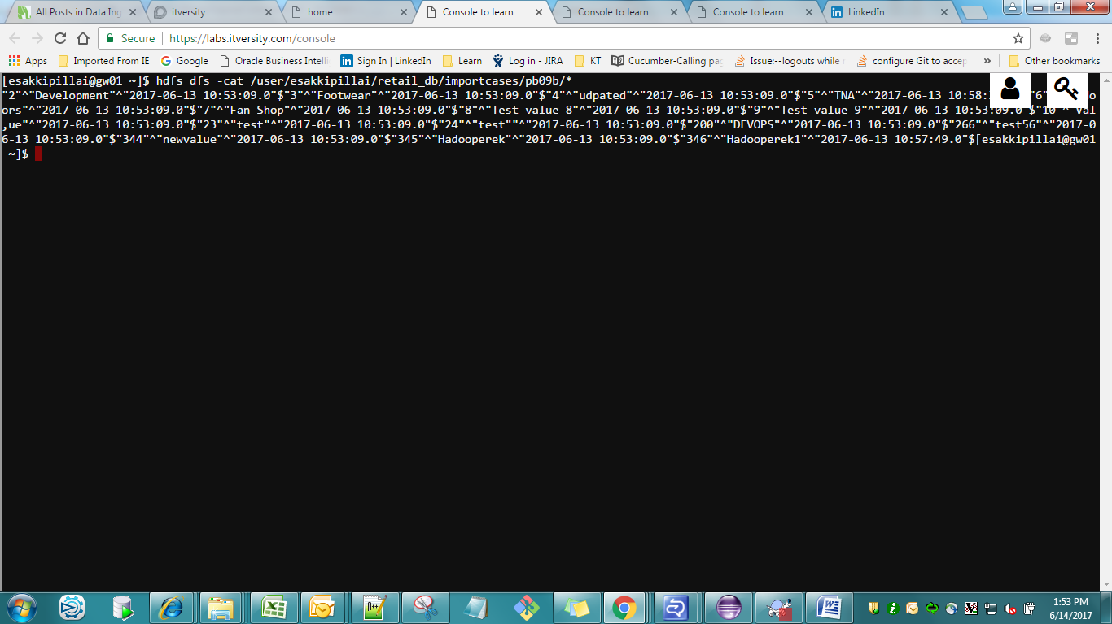

Pbm 10 :- Store the File in Parquet File Format

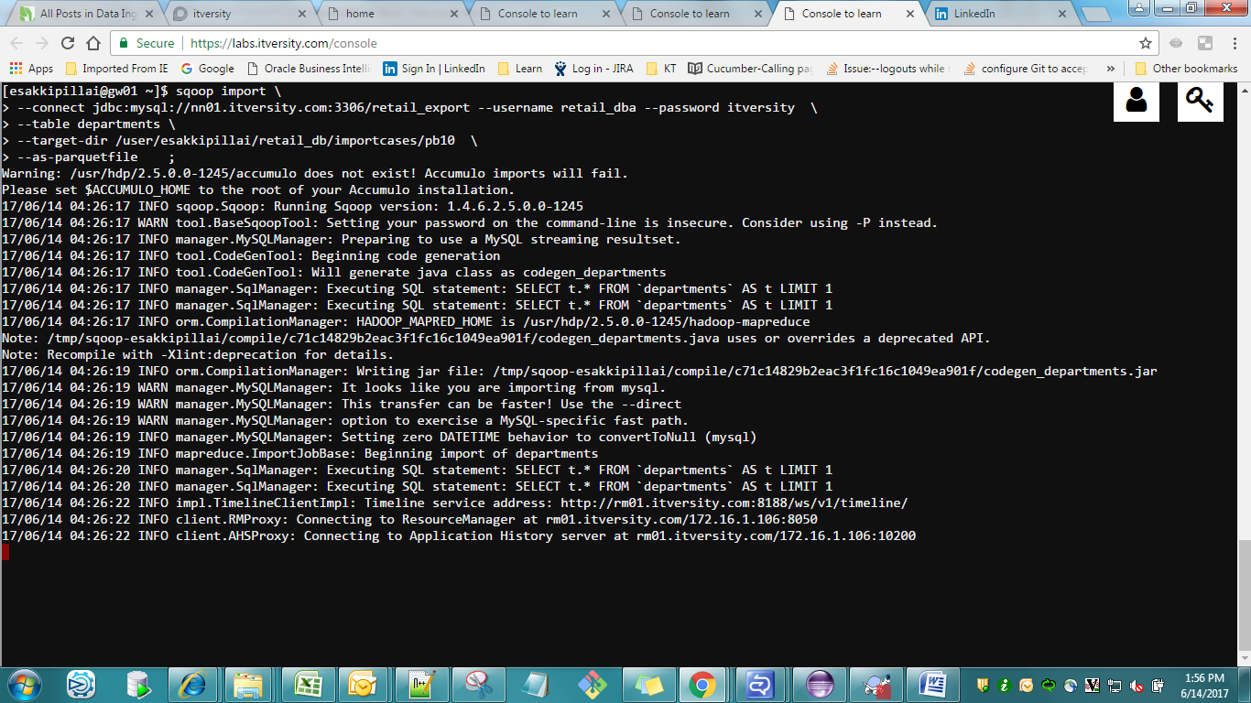

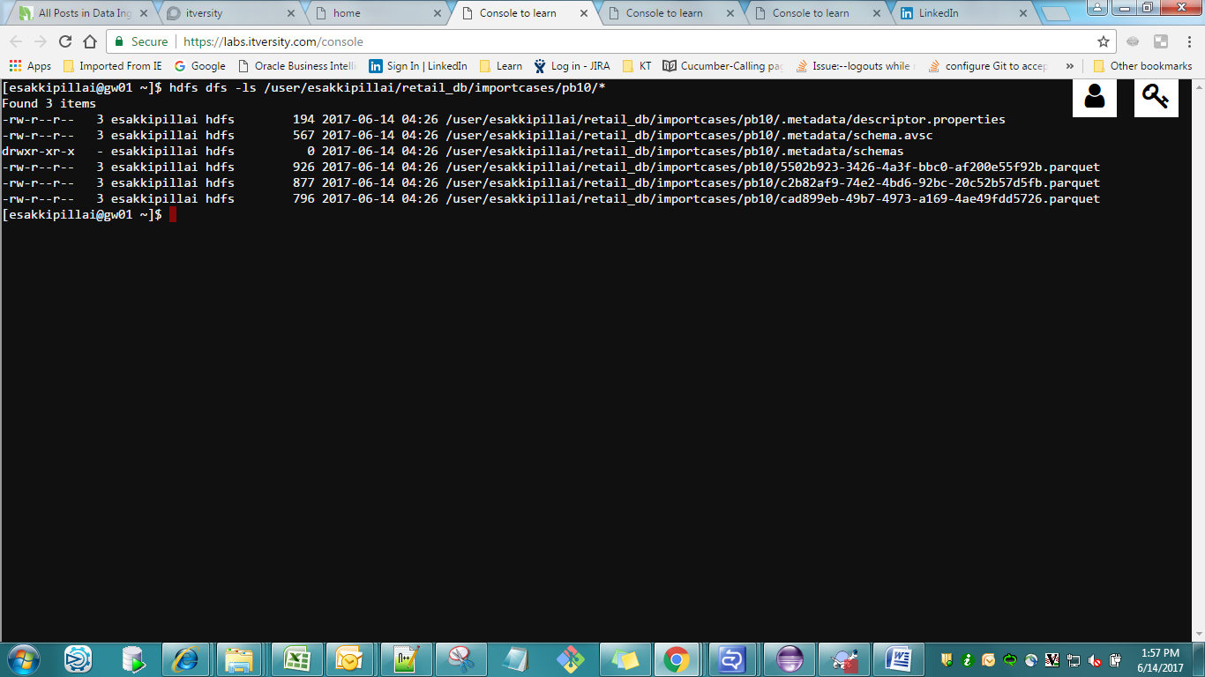

Pbm 11:- Normal Import from a Table to HIVE

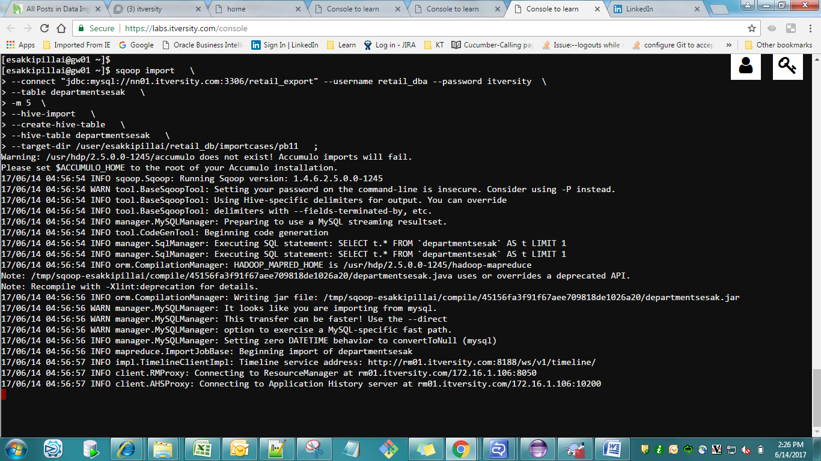

Import the data in to sqoopesak db

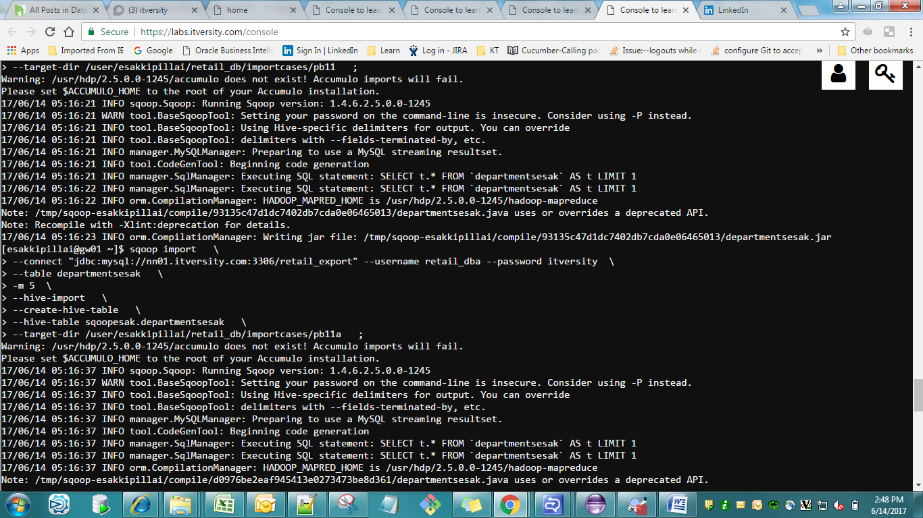

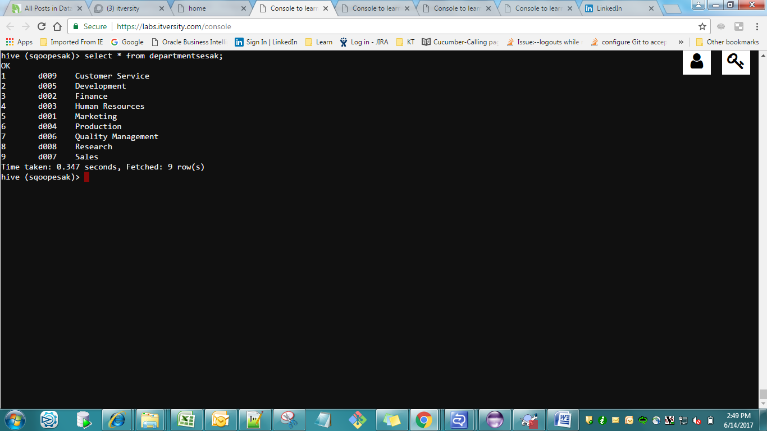

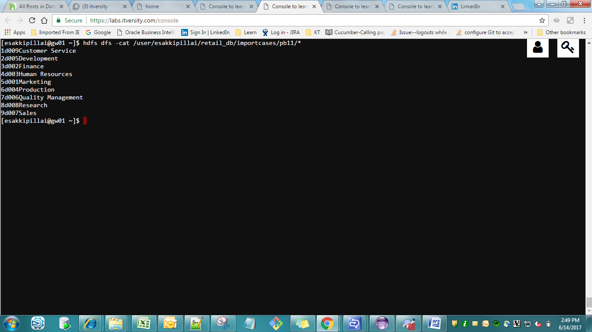

Output

[esakkipillai@gw01 ~]$ hdfs dfs -cat /user/esakkipillai/retail_db/importcases/pb11/*

1d009Customer Service

2d005Development

3d002Finance

4d003Human Resources

5d001Marketing

6d004Production

7d006Quality Management

8d008Research

9d007Sales

Importing into hive with custom delimiters

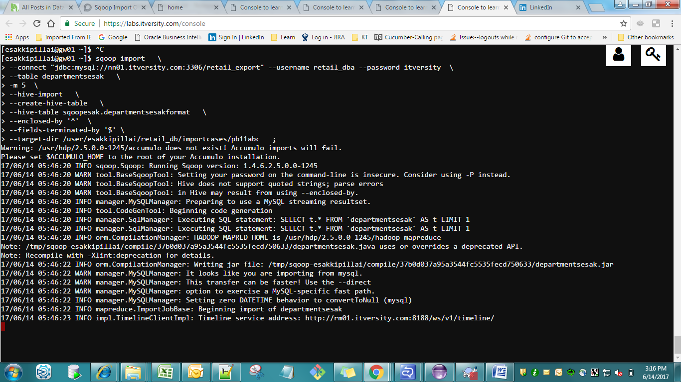

Fields $ enclosed by $

Pbm 12 :- Overwrite the Table Data from Mysql into Hive

Pbm 13:- Hive import using Partitioning

select * from categories_exp where category_department_id IN (3 ,5 7,)

1. Create a new Hive Table and sqoop the below Commands
2. Overwrite the hive Table using the below sqoop Commands

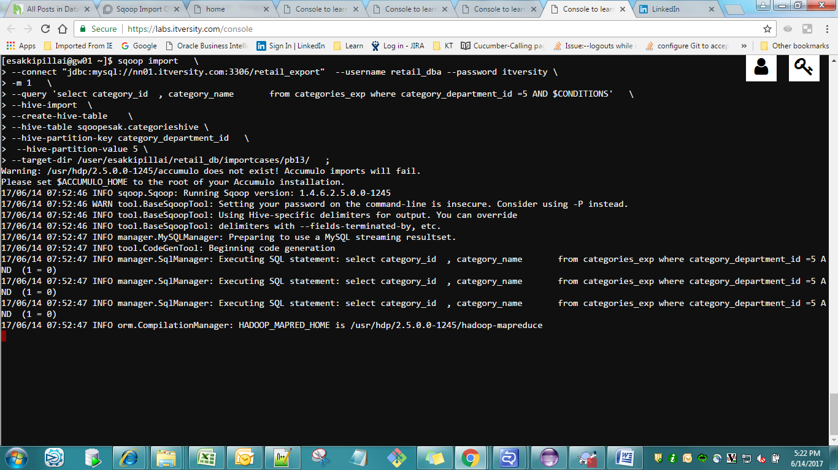

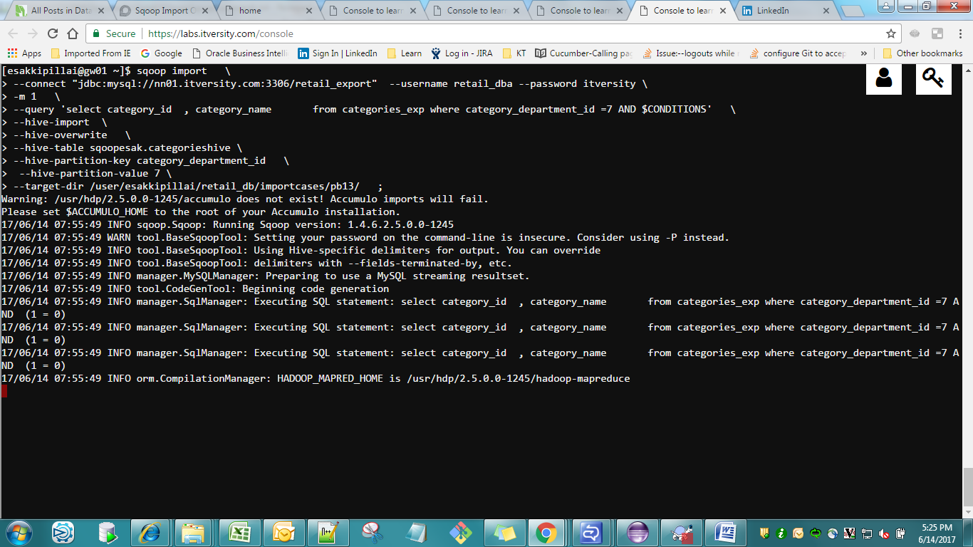

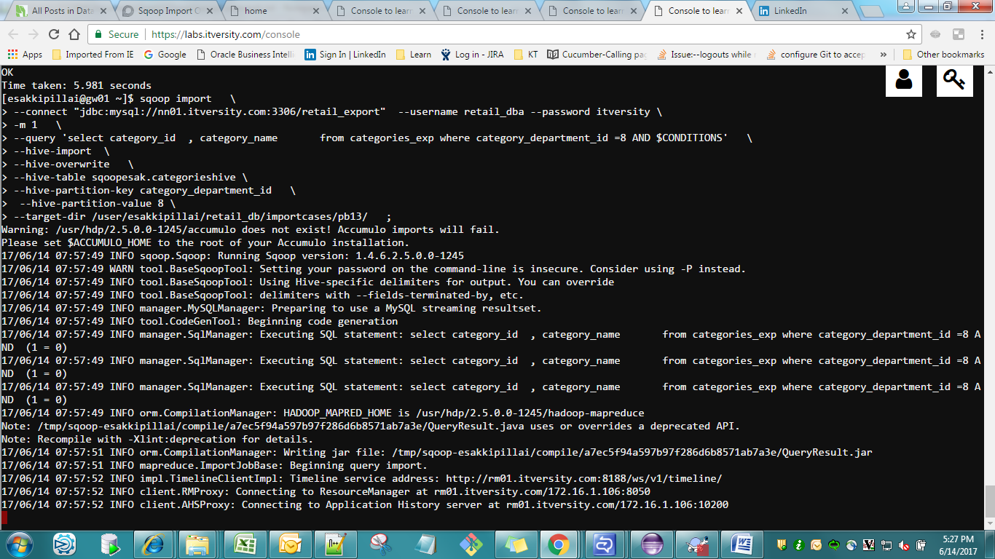

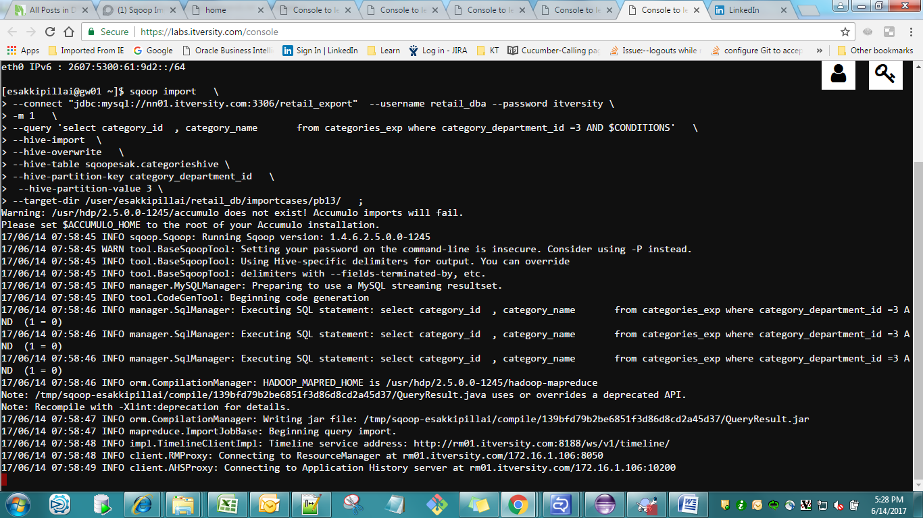

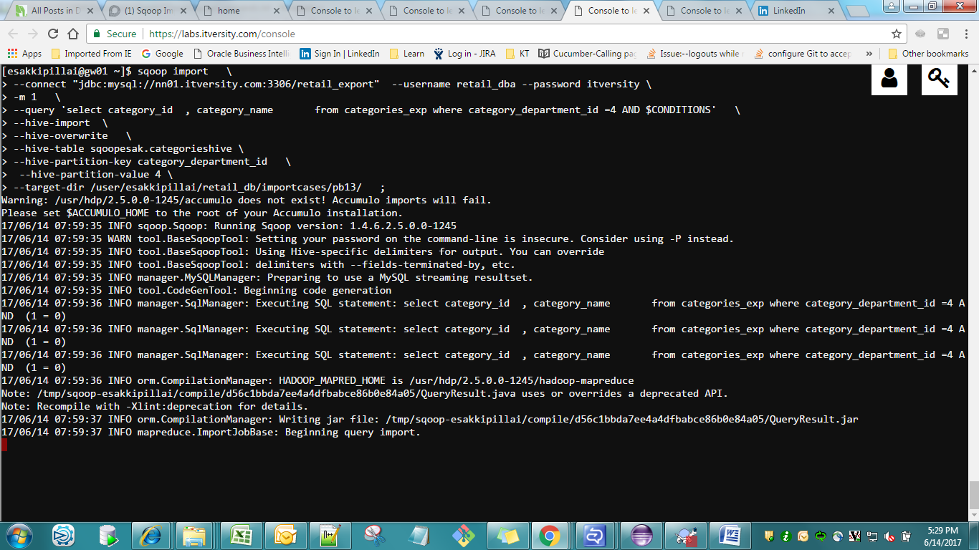

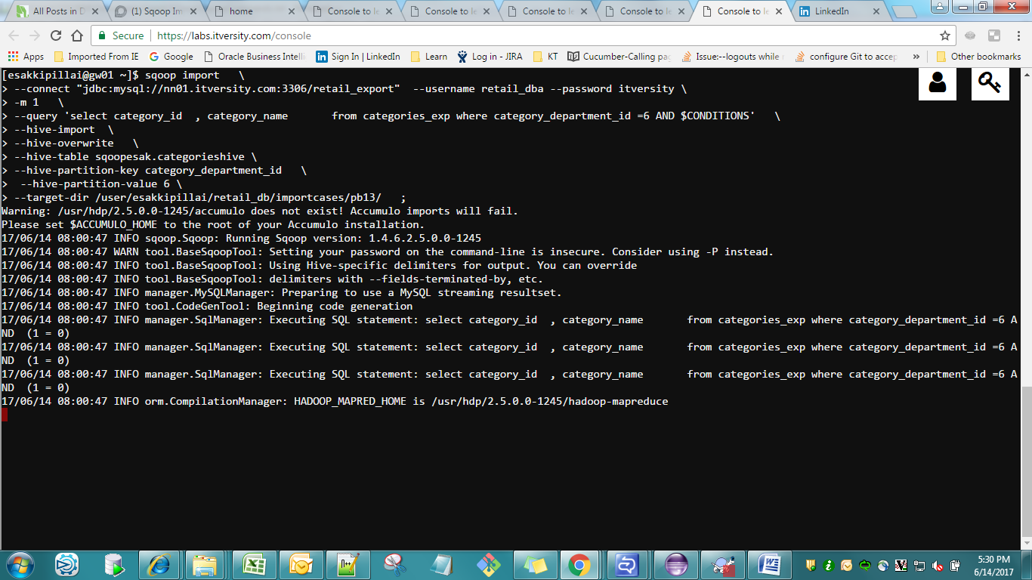

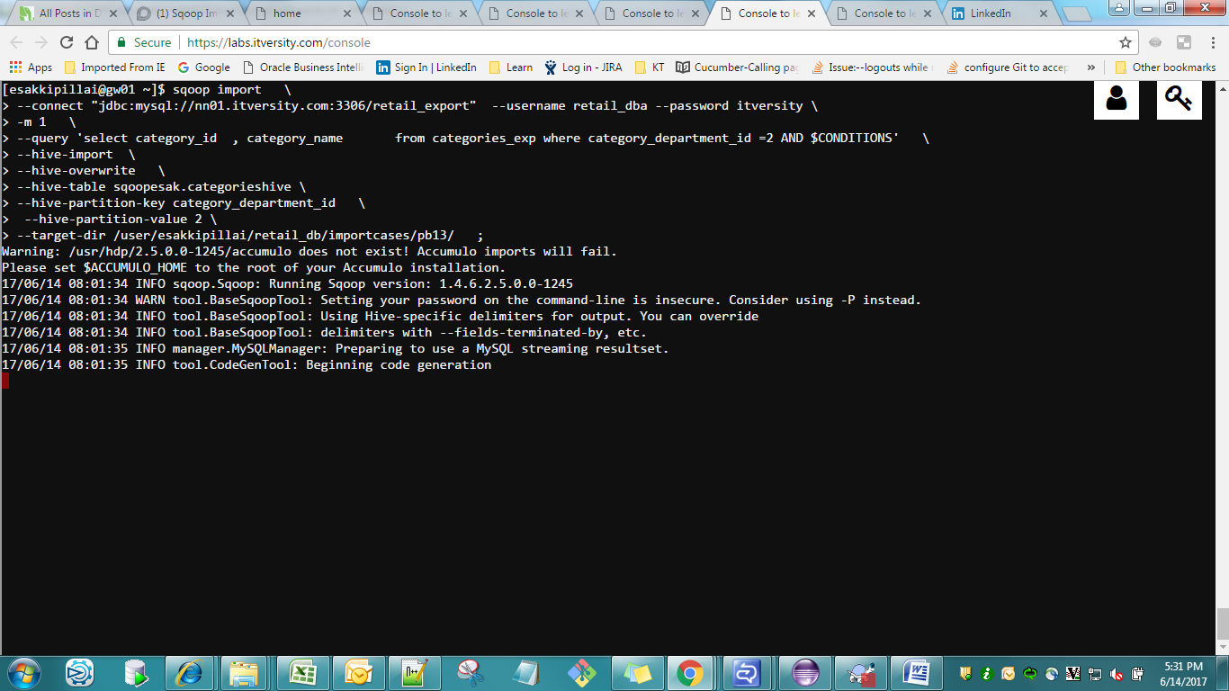

Verification in Hive

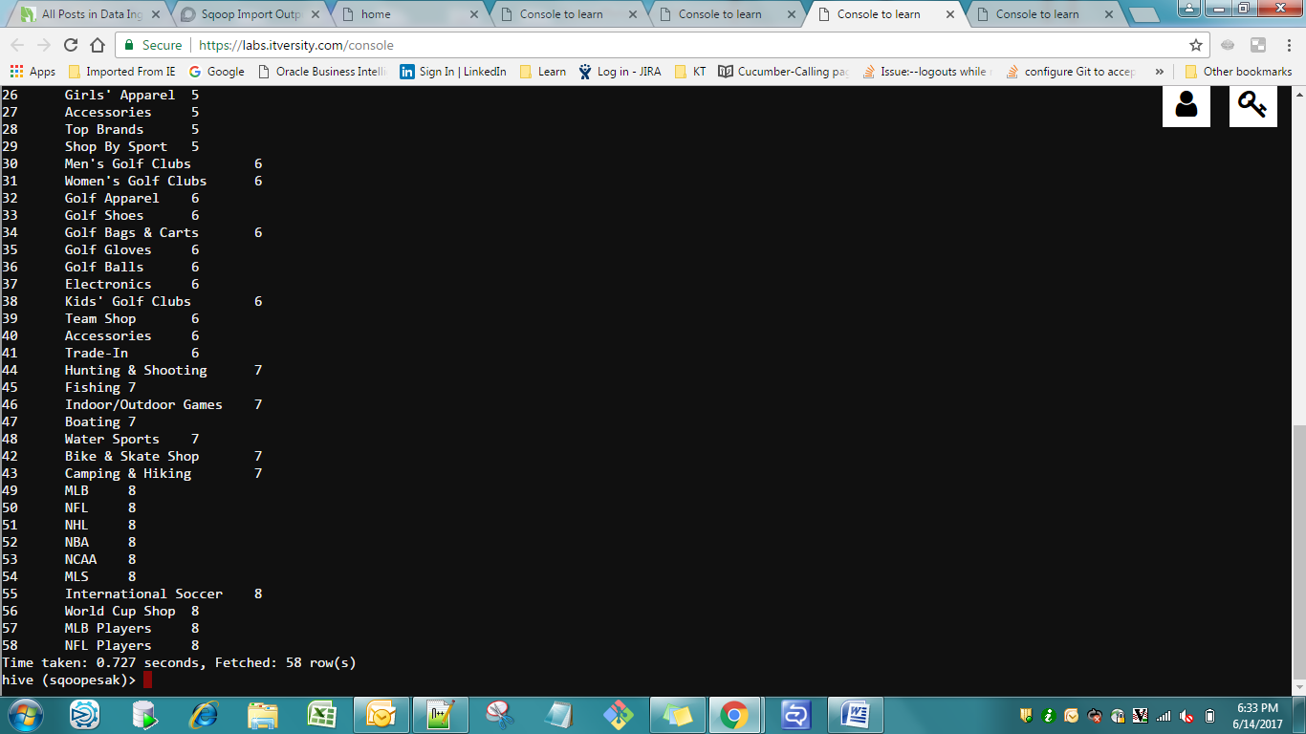

Checking In HDFS

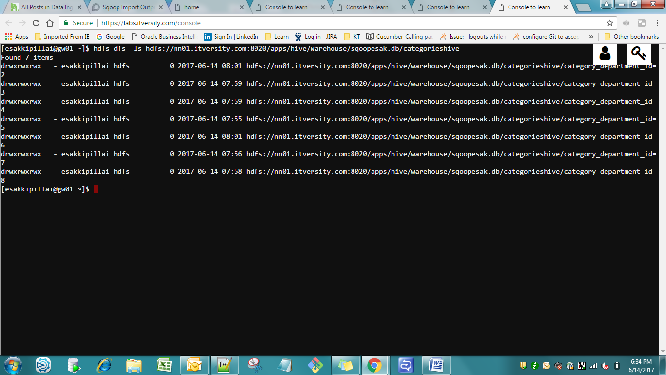

Export

Pbm01

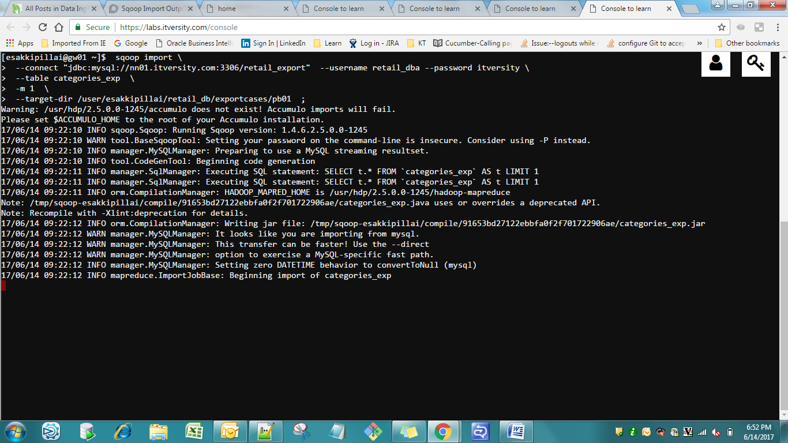

Data in HDFS



Pbm 1a

Basic Export – export the data back to Mysql

Created Mysql table

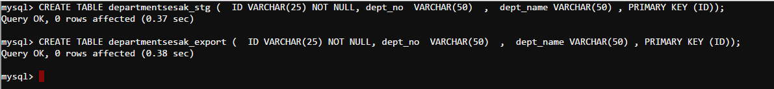

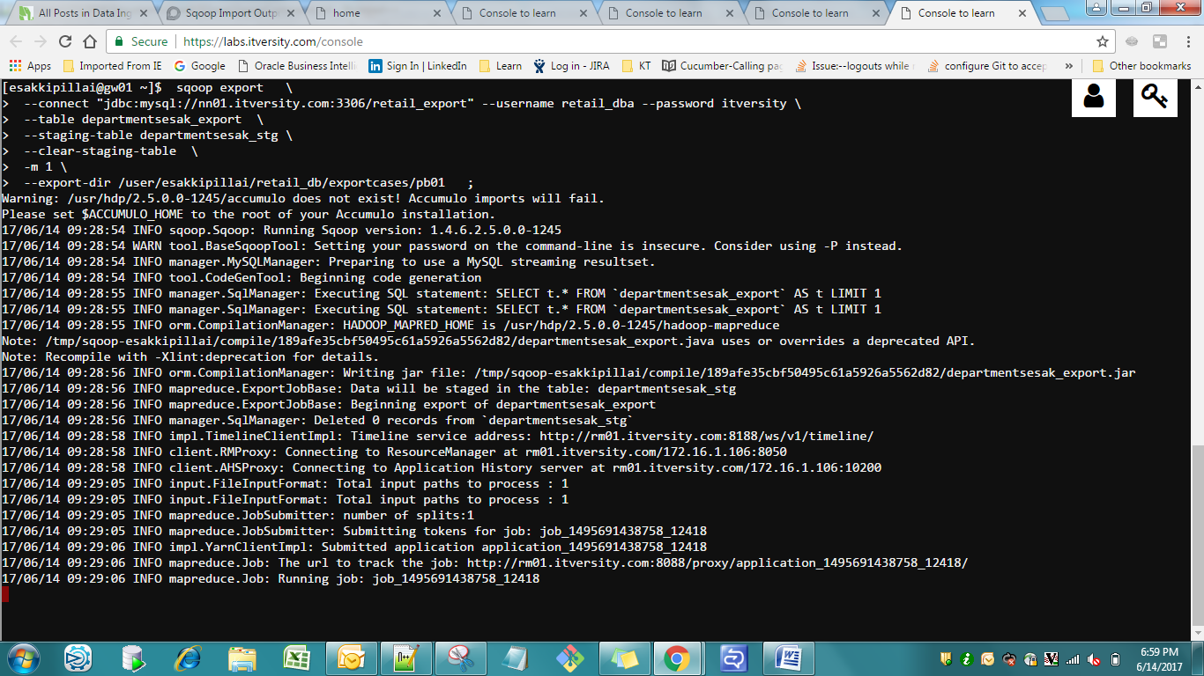



1b) Without Staging Table

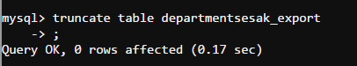

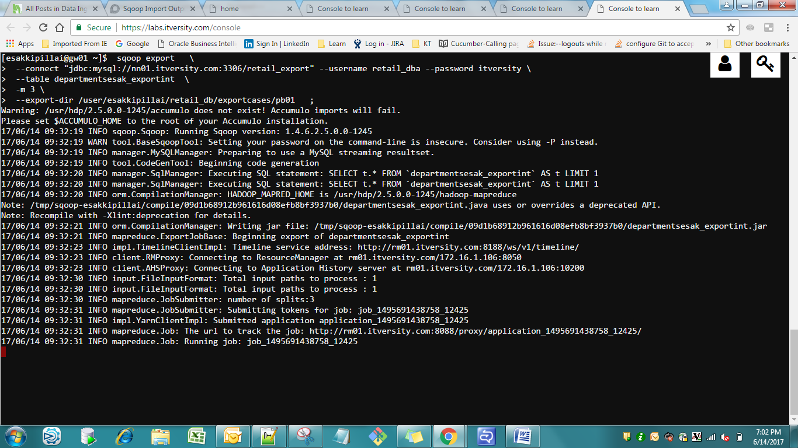

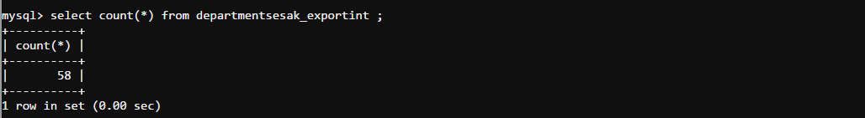

Pbm 02 Export in Update mode

Update mode

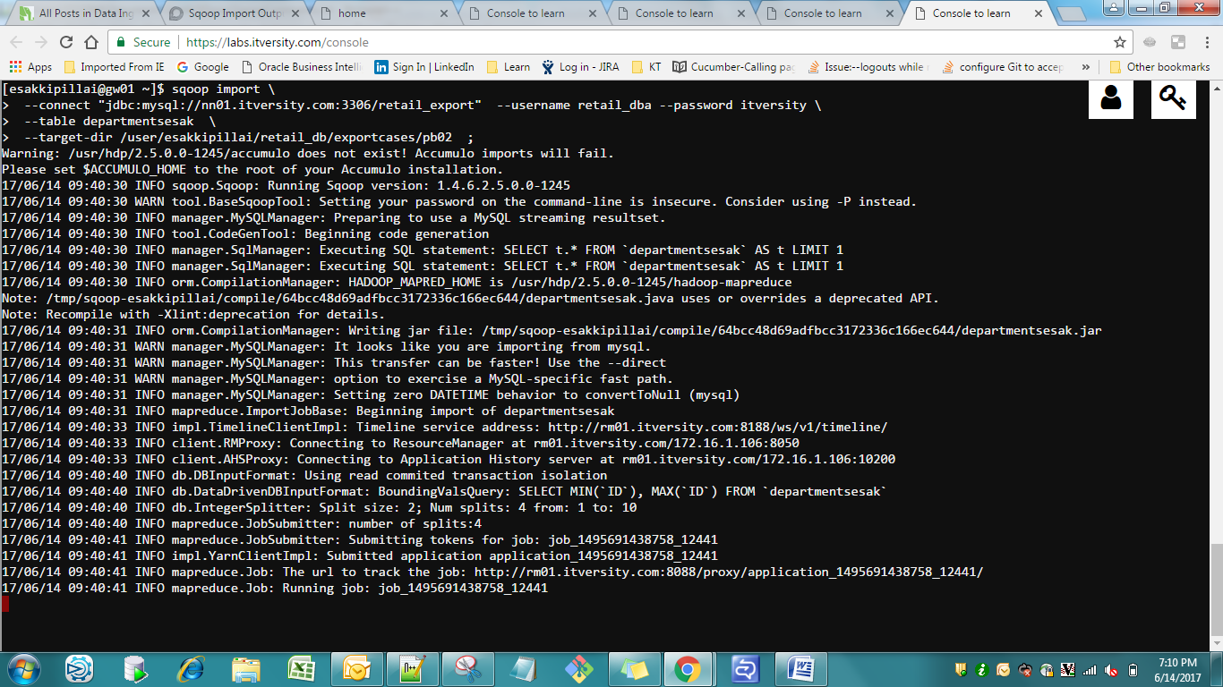

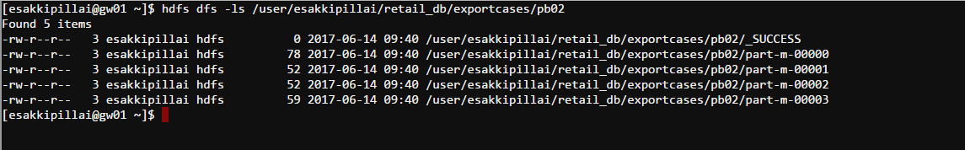



Doing Normal Export

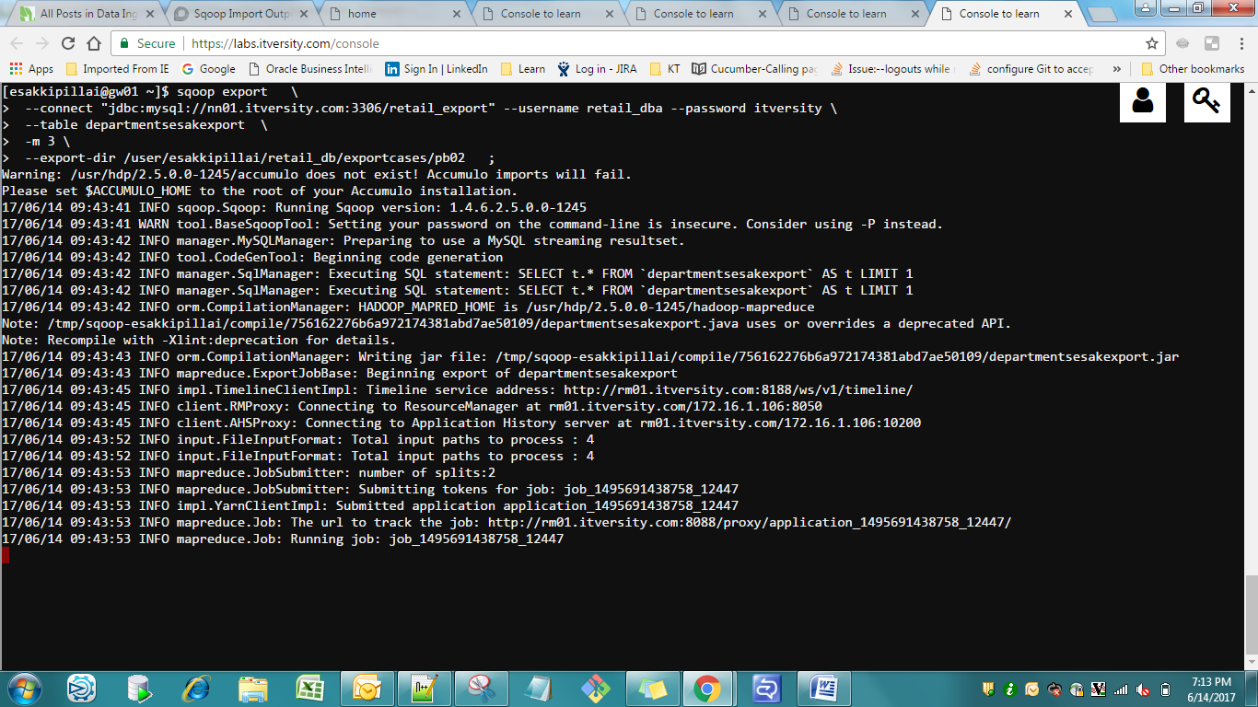

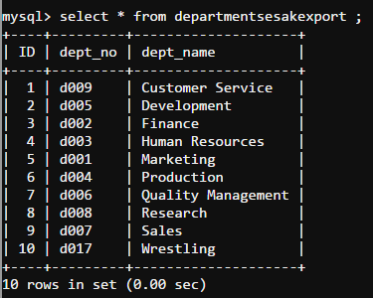

Updating departmentsesakexport table

We are going to insert 2 rows

We are going to update 2 rows

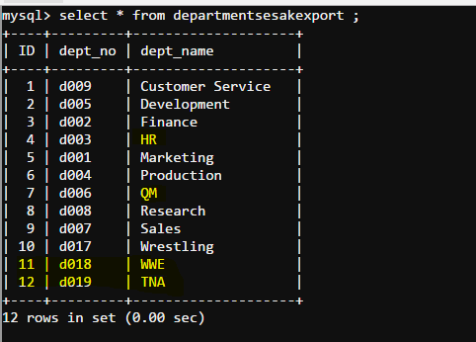

Updated data available in the HDFS “/user/esakkipillai/retail_db/exportcases/pb022 “

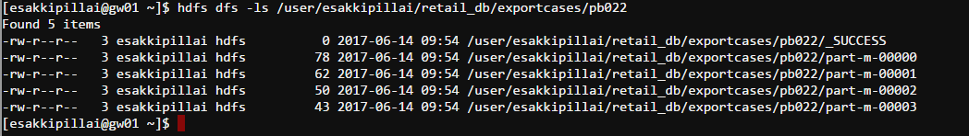

Export the data back to the original Table departmentsesak

Only for updated record

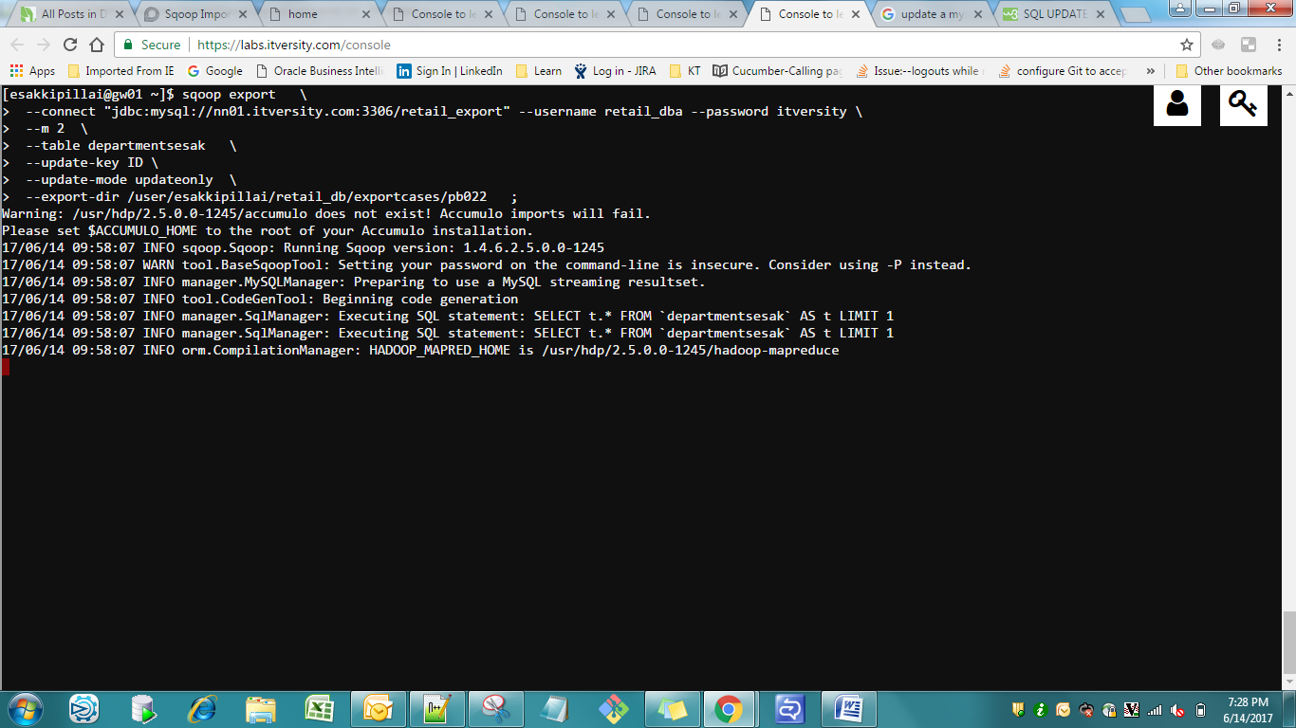

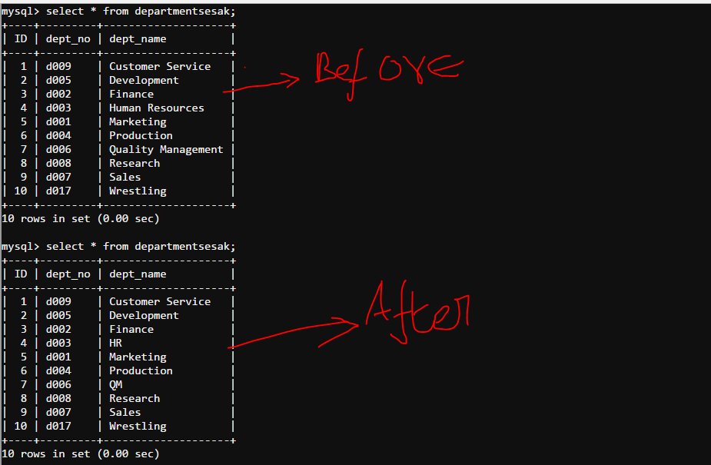

upinsert Mode update if not insert

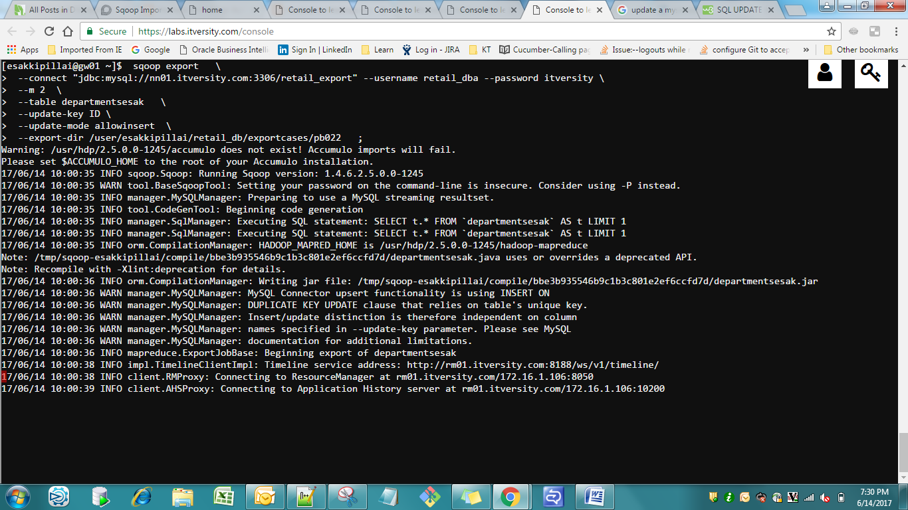

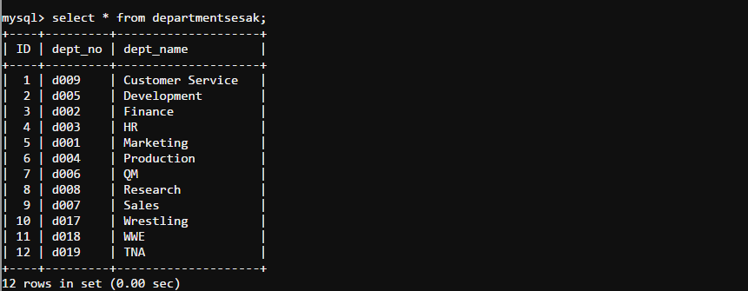

Pbm 3 Export Back to Hive;

Original Data in Hive

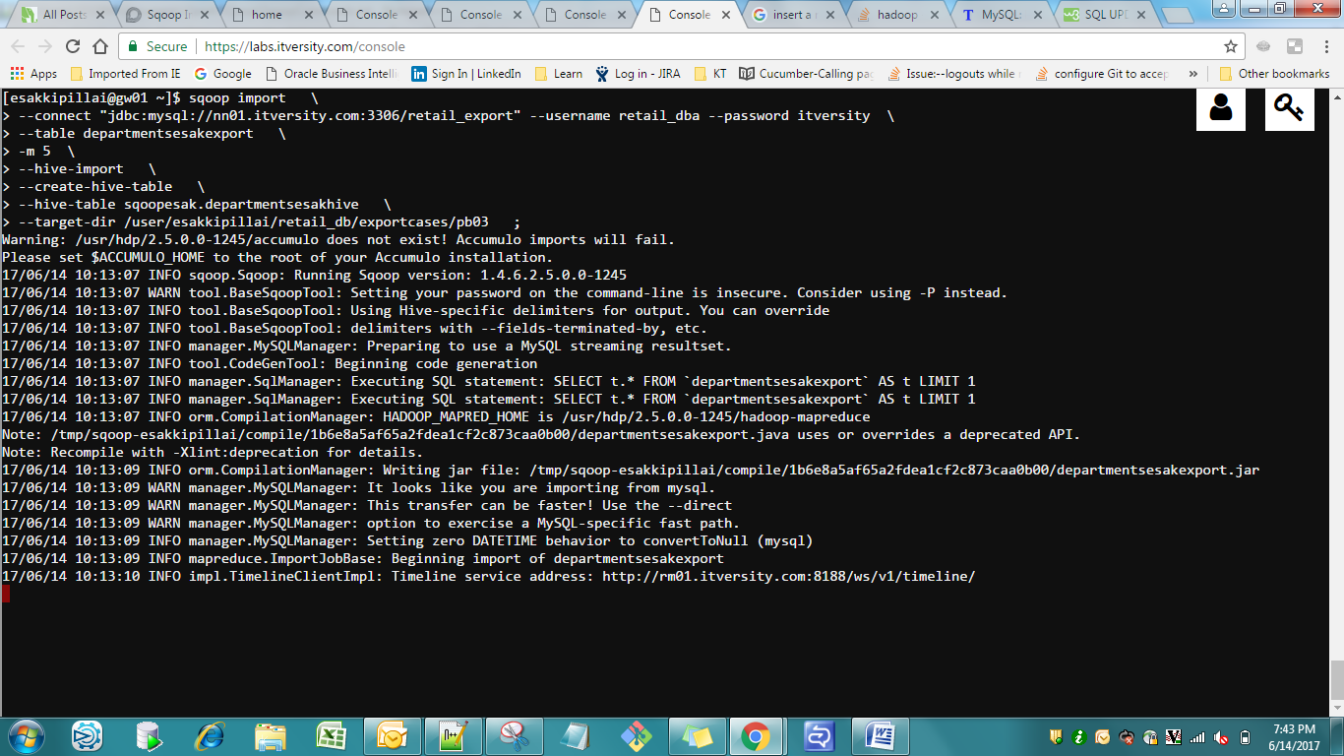

HIVE

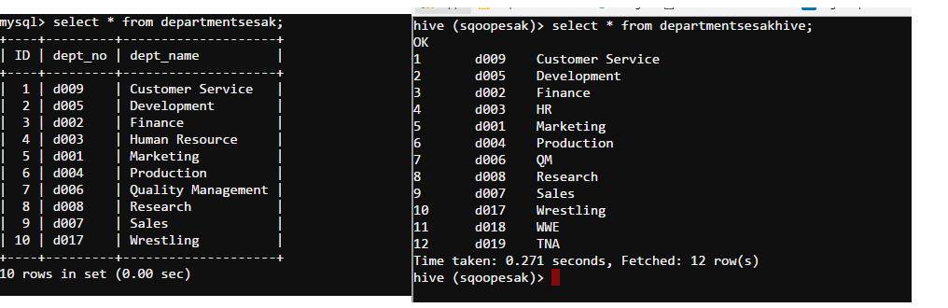

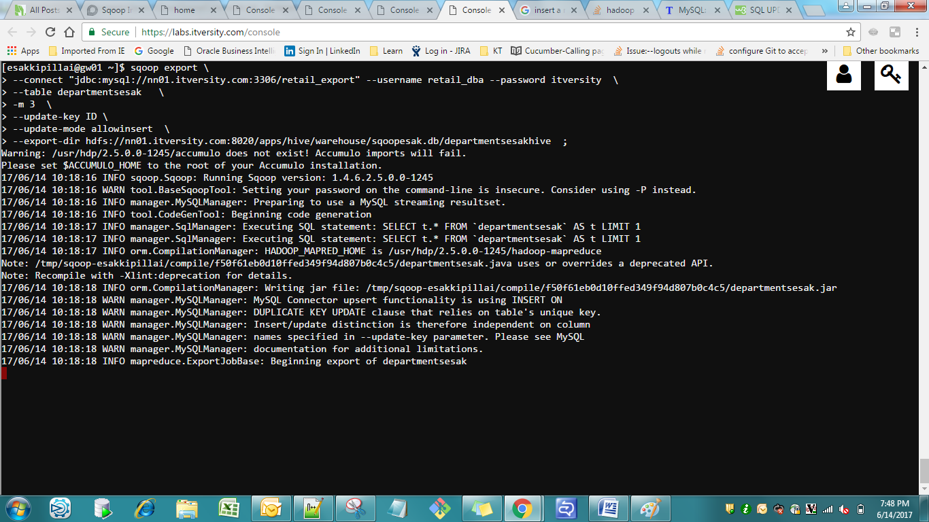

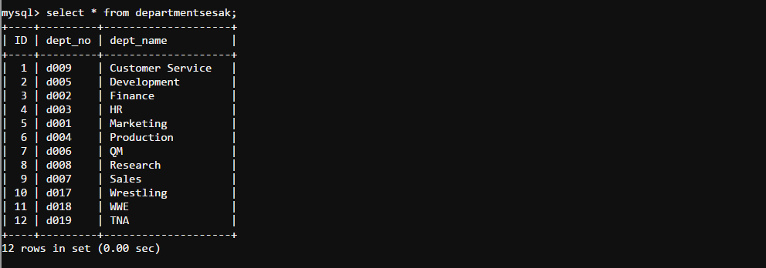

While Exporting we have to specify the Lines Delimiter as well

Pbm 4 eval import

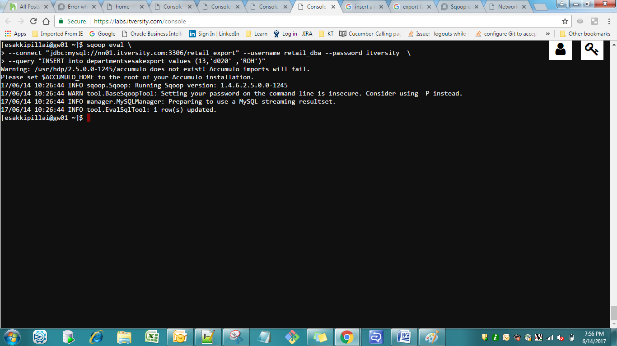

Sqoop Jobs

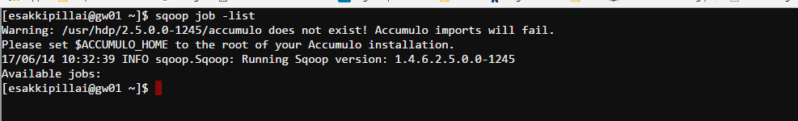

Sqoop Merge Process

Step 1 : Initial Load

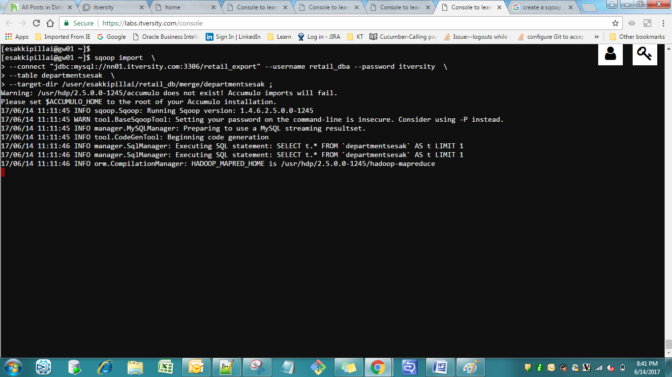

Step2

Updated Records

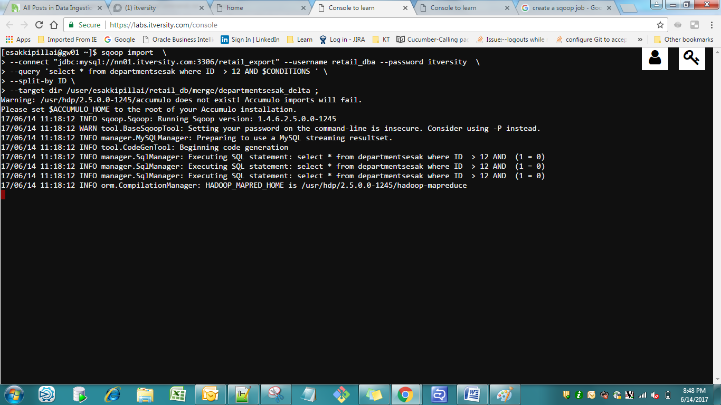

Pbm 5 : Append

